To: Scrutiny Committee

Date: 30 June 2015

Report of: Head of Community Services

Title of Report: a report on the performance of the Council’s leisure management contract with Fusion Lifestyle, covering the period from April 2014 to March 2015.

Summary

Purpose of report: To provide a performance update of the city’s leisure management contract with Fusion Lifestyle, April 2014 to March 2015.

Key decision: Yes

Executive lead member: Councillor Mike Rowley,

Report author: Head of Community Services

Policy Framework:

- Strong, Active Communities
- Efficient, Effective Council

Appendix One - Leisure Centre Capital Investment
Appendix Two - Leisure Centre Subsidy per visit by Facility, 2014/15
Appendix Three - Leisure Centre visits 2008 to 2015
Appendix Four - Leisure Centre visits 2014 to 2015
Appendix Five - Leisure Centre Target group visits 2009 to 2015
Appendix Six – Sports and Community Development Outreach pictures Appendix Seven (a) - Carbon measurements 2013 to 2015 – Including facilities closed in December 2014.
Appendix Seven (b) - Carbon measurements 2013 to 2015 – with Leys Pools and Leisure Centre open, December 2014.
Appendix Eight - Leys Pools and Leisure Centre Sports Hall Lighting

Background

  - In March 2009 the council entered into a contract with Fusion Lifestyle (Fusion), a social enterprise with charitable status, to manage the Council’s Leisure Facilities. The initial contract was for ten years, with a five year extension clause.

  - The contract has greatly improved the user experience, alongside achieving cumulative revenue savings of around £1,360,000 per year.

  - Over this period, facilities have been greatly improved with around £14.4 million of capital investment, which has in the main been funded by the contract savings. (Appendix One - Leisure Centre Capital Investment)

  - In February 2014 the City Executive Board agreed to enact the extension clause and extend the contract to for the development, management and operation of the City’s leisure centres for a five year period to April 2024.

  - The cost of the core leisure management contract to the council is fixed according to an agreed payment schedule for the period of the contract. The fee has reduced following investment in improved quality facilities, and is based on charging a market rate for those who can afford it, whilst offering concessions to those on low incomes.

  - The Council has a contractual relationship under which the council’s leisure facilities are managed by Fusion. The Leisure Management Agreement sets out the range of contractual requirements with which Fusion must comply. Fusion’s delivery of their Annual Service Plan is a contractual commitment.

  - In 2014/15 The Leisure Management Contract incorporated the service delivery of the Council’s seven leisure facilities;

- Barton Leisure Centre
- Leys Pools and Leisure Centre
- Blackbird Leys Swimming Pool (Closed December 2014)
- Ferry Leisure Centre
- Hinksey Outdoor Pool
- Oxford Ice Rink
- Temple Cowley Pools (Closed December 2014).

  - The final action of the Leisure Facilities Strategy 2009 was completed in December 2014; Temple Cowley Pools and Blackbird Leys Pool were closed and replaced by the new Leys Pools and Leisure Centre.

  - This report sets out performance of the leisure facilities managed on behalf of the Council by Fusion April 2014 to March 2015, and where comparison data is available performance against previous year’s delivery.

  - The committee have asked for a significant volume of information within this report and as such as lot of officer time has been spent on collating the data. It is proposed that a dashboard report is used to update on the contract going forward.

Value for money

  - The annual number of visits, management fee and contract utilities costs for March 2009 onwards has been used to demonstrate the overall subsidy per visit. This is an industry based calculation and allows us to consistently performance benchmark delivery of leisure management.

  - The pre transfer subsidy for leisure centres was £2.33 per visit. The subsidy per visit in 2014/15 reduced to £0.54.

  - The 2014/15 subsidy per visit by facility is demonstrated in Appendix Two - Leisure Centre Subsidy per visit by Facility 2014/15.

  - Competitor benchmarking against neighbouring leisure providers demonstrated that fees and charges in city leisure facilities continue to be at least comparable.

  - Since commencement of the contract there has been no increase to the price of the Bonus concessionary membership scheme. This offer gives those in receipt of one of 15 eligible benefits, and their dependents, reduced rates on activities at all our leisure facilities.

  - The five year extension to April 2024 guarantees a saving to the Council, resulting in the operation of the leisure centres reducing to approximately zero cost by 2017/18.

  - Savings from the contract with Fusion are already reflected in the council’s budget and the risk for achieving these is Fusion’s.

  - The management agreement contains provisions to share profits that are made above those agreed when the contract was agreed. No overall surplus above contracted performance was achieved in the 2014/15 period, so profit share arrangement does not apply.

Participation

3.2 The overall number of visits to leisure facilities in 2014/15, more than 1.3 million, increased 53 per cent since contract commencement; 450,000 more visits per annum when compared with the period prior to the transfer to Fusion. (Appendix Three - Leisure Centre visits 2008 to 2015; Appendix Four Leisure Centre visits 2014 to 2015).

3.5 In 2014/15 the number of visits to leisure facilities by target groups increased 134 per cent from the 2009/10 baseline year. The biggest percentage uplift is in target groups. 276,000 more visits per annum to leisure facilities when compared with the first year of the contract.

 | Visits 2009/10 | Visits 2014/15
Young People | 70,866 | 169,586
Older People | 42,684 | 107,814
People with Disabilities | 5,046 | 17,072
People from Ethnic Minorities | 17,406 | 86,379
Users from areas of deprivation | 70,115 | 101,159

(Appendix Five - Leisure Centre Target group visits 2010 to 2015)

3.6 The number of visits by Women and Girls has increased 6 per cent year on year; an increase of more than 24,500 visits. Leys Pools and Leisure Centre had a noted increase of more than 36,000 visits for women and girls.

3.7 Swimming by older people has increased year on year by 55 per cent; just under 12,500 more visits.

3.8 Under 17’s free swimming increased year on year 36 per cent; more than 13,400 visits.

3.9 More than 104,000 Learn 2 swim programme and schools swimming lessons were completed in 2014/15.

Sports and Community Development

4.1 Fusion’s Oxford Sports and Community Development Manager (SCD) works closely with the Council’s existing team and with other relevant partners to identify and deliver effective sports development processes and delivery.

4.2 The SCD Manager works alongside the Oxford Divisional Business Manager and each of the General Managers to develop facility sport programmes, to work with local partners and to create a structure for successful delivery of sport and physical activity across facilities.

4.3 Fusion work with a wide range of National Governing Bodies recognised by Sport England, such as:

- Amateur Swimming Association
- English Squash and Racketball
- Badminton England
- National Ice Skating Association
- Royal Lifesaving Society
- British Gymnastics

  - Examples of local stakeholders include:

- City of Oxford Swimming Club
- Community Organisations
- Education and schools
- Older & Youth People representatives
- Oxford Sports Partnership
- Oxford Swans Disability Swimming
- Oxfordshire County Council
- Public Health practitioners
- User Group representatives

  - Working in partnership with the Council, Fusions Commonwealth Games event at Leys Pools and Leisure Centre engaged more than 350 city primary school pupils.

- Orchard Meadow
- Windale Primary
- St Mary and St John.

The event consisted of 25 minute taster sessions of Commonwealth Games sports, including netball, badminton, athletics, table tennis and boxing fitness. The event was divided up into morning sessions for years 3 and 4 students and afternoon sessions for years 5 and 6.

4.6 Working in partnership with Oxford Community Badminton Network consisting of representatives from Oxfordshire Sports Partnership, Oxford City Council and Oxfordshire Badminton, 95 young people engaged with a Badminton Bisi Festival.

4.7 Fun Fitness Sessions were delivered to approximately 500 children across city primary school events including:

- Commonwealth Baton Relay Event
- Headington World Sports Day

4.8 50 young people from local primary schools visited the Leys Pools and Leisure Centre for a water safety talk provided by Fusion followed by a tour of the development site.

4.9 Fusion attended a wide range of community outreach events across the city including:
Headington Festival & Family Sports Day | Oxford Brookes Fresher’s Fair
Baton Relay Event - Cutteslowe | National Older Peoples Day Event
Rose Hill Activity Day | Oxford University Fresher’s Fair
Barton Bash | Florence Park Festival
Blackbird Leys Fair | Littlemore Play day
More Life Weight Management group talks

At each event they offered a row challenge and took the Oxford Mascots Marvin the penguin or Ollie the Octopus. (Appendix – Sports and Community Development Outreach pictures).

  - Other projects delivered by Fusion include:

- Successfully transferring the learn to swim programme from two closed centre across to the Leys Pools and Leisure Centre
- A new swim school on-line management system - Learn 2 –was introduced to Oxford pools and swimming instructors. A parent portal will follow soon giving real time updates on pupil progression.
- Successful mapping for development of the Learn 2 swim programme have swimming stages 1 to 7 being available at one time.
- Creation of a new group working with the City of Oxford Swimming Club to reduce drop out from swimming from the club and create an exit route from learn to swim programme.
- Exercise on Referral scheme; generating 126 users.
- Enhancing partnerships with Badminton England – Leys Pools and Leisure Centre and Ferry Leisure Centre are play badminton sites
- Creating new 50+ weekly programmes.
- Winter swim at Hinksey Outdoor Pool; 88 swimmers taking part.

Carbon Management

5.1 A reduction in CO₂ has been achieved against a backdrop of a large increase in participation in 2015/ 16 compared to the previous year. A ca18 per cent reduction in CO₂ per visitor has been observed which indicates good progress with data as follows:

2.38 CO₂ per visit /kg CO₂ in 2014/ 15 compared to 2.92 in 2013/14

5.2 Further detail per site is shown in the two tables in Appendix Seven (a) - Carbon measurements 2013 to 2015 – Including facilities closed in December 2014 and Appendix Seven (b) - Carbon measurements 2013 to 2015 – with Leys Pools and Leisure Centre open, December 2014.

5.3 The council Energy team assisted by the Leisure team has continued to work with Fusion to implement energy efficiency/carbon reduction projects in leisure centres throughout the year.

5.4 In March 2015 a trial of two boiler optimisation units (M2Gs) at Barton Leisure Centre commenced with the aim of reducing unnecessary gas consumption due to boiler standing losses (dry-cycling). The proposed savings achievable are 12 per cent based on typical savings achieved with M2G units which equates to estimated savings of around £3,168 per year or 19.5 tonnes of CO₂ per year. The units are being monitored using the smart meters at the centre (which give more detailed consumption data) over the summer 2015 to assess performance in more detail.
.
5.5 Energy efficiency/carbon reduction projects to reduce electricity consumption, CO₂ emissions and energy costs have been implemented at Leys Pools and Leisure Centre with low energy lighting and controls being installed in the Sports Hall and also the Gym suite areas. The Sports Hall lighting project, (Appendix Eight - Leys Pools and Leisure Centre Sports Hall Lighting) is estimated to reduce:

- electricity consumption at the site by 41,800kWh
- annual electricity spend by an estimated £5,024
- carbon emissions by around 22.6 tCO₂ per year

The Gym lighting project, where LED lights and controls have been installed at the Leys Pools and Leisure Centre, is estimated to reduce:

- electricity consumption at the site by 26,000kWh
- annual electricity spend by an estimated £3,118
- carbon emissions by around 14 tCO₂ per year

Quality Assurance

  - A Performance Failure occurs in the event that Fusion fails to meet the requirements of the Performance Standards. In the case of failures, Fusion are given a defined rectification period in which to correct the failure without incurring any deduction.

  - Performance Failure that is not rectified within the relevant Rectification Period is deducted from the core management fee payment, this equated to a deduction payment of £10,250 in 2014/15.

  - Fusion has maintained International Standards 14001, 14002 and 9001 following external assessments.

  - Quest is designed primarily as a tool for continuous improvement for the management of leisure facilities and leisure development. It defines industry standards and good practice and encourages on-going development within a customer focused management framework.

  - Five leisure facilities continue to be accredited with the UK quality award scheme for sport and leisure, QUEST:

Barton Leisure Centre
(Quest Plus - Good)

Leys Pools and Leisure Centre
(Quest Plus - Good)

Ferry Leisure Centre
(Quest Plus - Good)

Hinksey Outdoor Pool
(Quest Entry – Registered)

Oxford Ice Rink
(Quest Plus - Good)

Quest Plus is a 2 year cycle made up of:
Year 1
- A mystery visit and a two day assessment. The centre will be assessed on the eight Facility Management core modules on day 1 and 5 modules of their choice on day two (one of these 5 modules will be un-scored.
- The overall bandings range from Unsatisfactory, Satisfactory, Good and Excellent.
Year 2
- A one day review and either an NPS (Net Promoter Closed Loop Survey) or a mystery visit.
Quest Entry is a yearly one day assessment where the centre will receive a mystery visit and a one day assessment on the eight Facility Management core modules of Purpose, People and Operations. The overall bandings are either Unsatisfactory or Registered.

Customer Service

7.1 Fusion Lifestyles customer care process includes an approach to

- Facility presentation
- Customer enquiries and complaints
- Customer comments.

7.2 Overall customer satisfaction in 2014/15 was 98 per cent; overall customer excellence rating was 55 per cent.

OVERALL % EXCELLENT/GOOD/SATISFACTORY
Knowledgeable, friendly staff | 99%
Range of activities | 98%
Condition of building | 91%
Cleanliness | 92%
Value for money | 97%
Equipment | 95%
Ease of booking and paying | 98%
Ease of gaining information | 98%
Website | 96%

Staffing

9.1 The Oxford Living Wage continues to be paid to employees and those engaged by Fusion in city leisure facilities.

9.2 In 2014/15 Fusions Oxford young apprentice gained full-time employment in a city leisure facility. Fusion are committed in 2015/ 16 to recruiting four apprentices across city facilities.

9.3 Just under 3,000 hours of learning and development has been completed by staff; 37 hours per permanent staff member.

Next steps

3.1 Fusions 2015/16 Annual Service Plan was endorsed by the City Executive Board in April 2015. Key objectives include:

- Accessible and affordable leisure opportunities through pricing structures at appropriate and inclusive levels.
- Improving health and well-being by positively promoting and delivering the benefits of healthy living and active lifestyles.
- Supporting the council’s Youth Ambition Programme
- Tackling climate change and promote sustainable environmental resource management providing quality through continuous improvement.
- Driving value for money by ensuring that the leisure offering is of a high standard and innovative.

3.2 There will be an on-going review and monitoring process for the leisure contact with Fusion Lifestyle. This will incorporate management scrutiny, monthly client performance reports, monthly meetings between key representatives of the Council and Fusion, quarterly Leisure Partnership Board meetings and a formal review in advance of the 2016/17 planning process.

Name and contact details of author:-
Name: Ian Brooke
Job title: Head of Leisure, Parks and Communities
Service Area / Department: Leisure, Parks and Communities
Tel: 01865 252705 e-mail: ibrooke@oxford.gov.uk

 |  |  | Year 1 |  | Year 2 |  | Year 3 |  | Year 4 |  | Year 5 | Year 6
Capital Scheme |  |  | 2009/10 |  | 2010/11 |  | 2011/12 |  | 2012/13 |  | 2013/14 | 2014/15 | Total Capital Expenditure
Barton Leisure Centre |  |  | 10,658 |  | 31,730 |  | - |  | - |  | - |  | 42,389
Blackbird Leys Pool |  |  | 3,245 |  | 55,796 |  | - 0 |  | - |  | - |  | 59,040
Blackbird Leys Leisure Centre |  |  | 62,932 |  | 107,985 |  | - |  | - |  | - |  | 170,917
Ferry Leisure Centre |  |  | 28,628 |  | 78,942 |  | - |  | - |  | - |  | 107,570
Hinksey Outdoor Pool (heated) |  |  | 52,454 |  | 86,474 |  | 23,501 |  | - |  | - |  | 162,429
Temple Cowley Pool |  |  | 14,163 |  | 84,331 |  | - |  | - |  | - |  | 98,494
Oxford Ice Rink |  |  | 40,822 |  | 759,309 |  | 93,460 |  | - |  | - |  | 893,591
Barton Leisure Centre Improvements |  |  | 79,815 |  | 602,287 |  | 173,572 |  | - |  | - |  | 855,673
Blackbird Leys Leisure Centre Improvements |  |  | 55,372 |  | 433,830 |  | - |  | - |  | - |  | 489,202
Ferry Leisure Centre Improvements |  |  | 60,117 |  | 657,523 |  | 1,961 |  | - |  | - |  | 719,601
New Build Competition Standard Pool |  |  | - |  | 561,929 |  | 355,817 |  | 21,337 |  | 2,628,073 | 5,849,953 | 9,417,109
Building Improvements (General Fund Leisure) |  |  | - |  | - |  | 107,316 |  | - |  | - |  | 107,316
Hinksey Pools Main Pool Liner |  |  | - |  | - |  | - |  | 117,400 |  | - |  | 117,400
Leisure Centre Substantive Works |  |  | - |  | - |  | 250,359 |  | 174,011 |  | 116,171 | 337,808 | 878,349
Leisure Centre Improvement Work |  |  | - |  | - |  | - |  | 276,762 |  | 4,258 | - | 281,019
Total |  |  | 408,206 |  | 3,460,135 |  | 1,005,986 |  | 589,509 |  | 2,748,502 | 6,287,761 | 14,400,100
Appendix One – Leisure Centre Capital Investment

Appendix Two – Leisure Centre Subsidy per visit by Facility, 2014/15

Facility | Subsidy per visit:
Barton Leisure Centre | 2.05
Leys Pool and Leisure Centre | 1.33
Blackbird Leys Pool (closed Dec 15) | 5.49
Ferry Leisure Centre | - 0.61 | Surplus
Hinksey Outdoor Pool | 3.00
Oxford Ice Rink | - 0.98 | Surplus
Temple Cowley Pools (closed Dec 15) | 3.07

Appendix Three - Leisure Centre visits 2008 to 2015

Appendix Four - Leisure Centre visits 2014 to 2015

Appendix Five - Leisure Centre Target group visits 2009 to 2015

Appendix Six – Sports and Community Development Outreach pictures

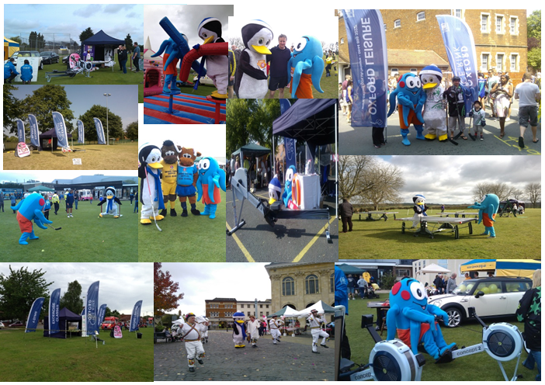
Appendix Seven (a) Carbon measurements 2013 to 2015 – Including facilities closed in December 2014

CMP Year 1 2013/14
 | CO2 per visit /kgCO2
Barton Leisure Centre | 3.18
Blackbird Leys Leisure Centre | 2.21
Blackbird Leys Pool | 6.54
Ferry Leisure Centre | 1.14
Hinksey Outdoor Swimming Pool | 6.05
Ice Rink | 4.49
Temple Cowley Pools | 6.80
Totals | 2.92
CMP Year 2 2014/15
 | CO2 per participant/kgCO2
Barton Leisure Centre | 2.81
Leys Pools and Leisure Centre | 1.62
Blackbird Leys Swimming Pool | 5.08
Ferry Leisure Centre | 1.07
Hinksey Outdoor Swimming Pool | 6.40
Oxford Ice Rink | 4.16
Temple Cowley Pools | 4.82
Totals | 2.38

Appendix Seven (b) - Carbon measurements 2013 to 2015 – with Leys Pools and Leisure Centre open, December 2014

CMP Year 1 2013/14
 | CO2 per visit /kgCO2
Barton Leisure Centre | 3.18
Blackbird Leys Leisure Centre | 2.21
Ferry Leisure Centre | 1.14
Hinksey Outdoor Swimming Pool | 6.05
Oxford Ice Rink | 4.49
Totals | 2.43
CMP Year 2 2014/15
 | CO2 per participant/kgCO2
Barton Leisure Centre | 2.81
Leys Pools and Leisure Centre | 1.62
Ferry Leisure Centre | 1.07
Hinksey Outdoor Swimming Pool | 6.40
Oxford Ice Rink | 4.16
Totals | 2.11

Appendix Eight Leys Pools and Leisure Centre Sports Hall Lighting

1. Project brief:

The purpose of this project is to reduce electricity consumption at the site, by specifying higher efficiency lighting with occupancy controls. This will result in lower electricity costs associated with a reduced lighting demand by the building.

The proposal specifies replacing the existing gas discharge high-bay lighting with efficient T5 fluorescent lighting and incorporating occupancy sensors to turn off lighting when the hall is vacant. These measures exceed Building Regulations and will improve the energy efficiency of the building.

A lighting simulation has been completed using Relux software with photometric data supplied by the manufacturer, which has produced the following calculation data and visual representation:

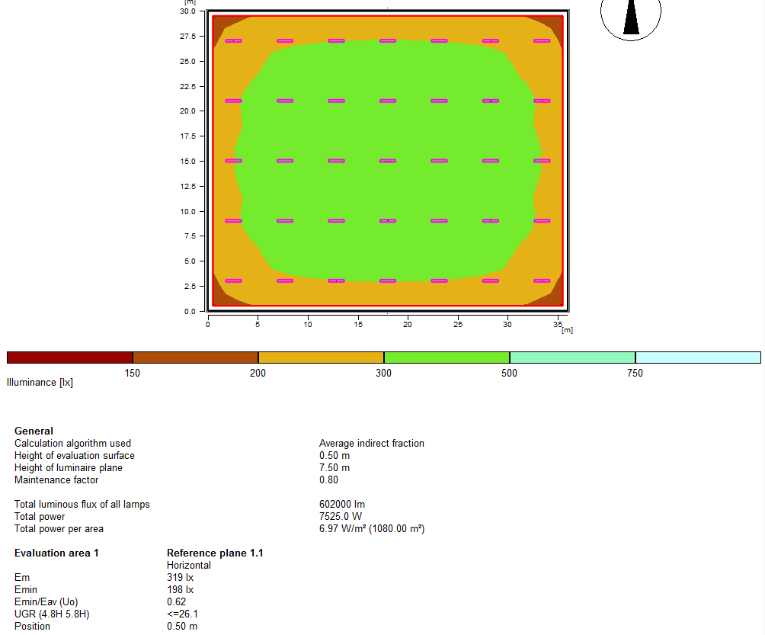

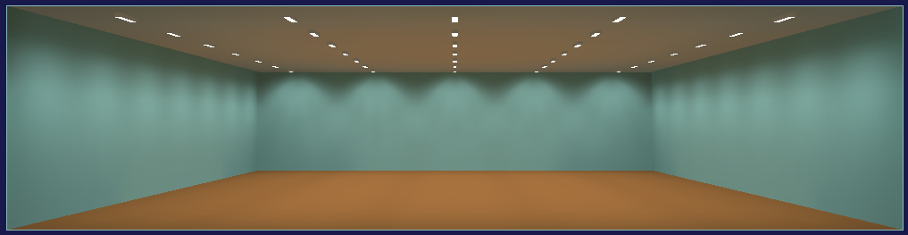
These calculations show that at 0.5 metres above floor level, the vast majority of the hall will exceed 300 lux with a uniformity rating (measure of lighting consistency) of 0.62. Sport England (Artificial Sports Lighting – Updated guidance for 2012) and British Standard (EN 12193:2007 Light and Lighting – Sports Lighting) quote 300 lux and a uniformity rating of 0.7 for most indoor sports at Class III: Community ‘level of play’. Visually there should also be a significant improvement in light levels compared to the existing setup.

2. Anticipated savings:

The survey, including estimated kWh/CO₂ savings, was undertaken by the Council’s Energy & Climate Change team, whilst project management including sourcing and installing the equipment will be undertaken by Fusion Lifestyle (the Council’s leisure provider) using their approved contractors.

The electricity savings estimates calculated by the Council’s Energy & Climate Change team are summarised in the following tables using the assumptions detailed below:

- Control gear in the existing luminaires consumes 15% of the rated lamp wattage
- Lighting in the sports hall is currently operational for 75% of the centre’s opening hours
- Occupancy controls will reduce the lighting operation time by 30%

The inclusion of occupancy controls will considerably reduce the payback period through delivering significant electricity savings for a small additional investment. The lighting manufacturer has advised on the most appropriate controls based on the existing wiring setup; this has now been confirmed and agreed with the installer and additional costs provided.

3. Payback calculations

ANNUAL RUNNING COSTS
 | Units | Rate | Cost
Existing gas discharge lighting with no control | 63,104 kWh | £0.12 / kWh | £7,572
Replacement fluorescent lighting with occupancy control | 21,241 kWh | £0.12 / kWh | £2,549
ELECTRICITY SAVING | 41,863 kWh |  | £5,023

PROJECT COSTS
Supply and installation of high frequency T5 fluorescent (4x49W) fittings suitable for sports halls | £12,410
Supply and installation of two occupancy sensors to control light fittings [costs confirmed following survey by installers] | £2007.36
TOTAL PROJECT COST | £14,417.68

PAYBACK
Project payback period | 2.9 years
CO₂ reduction per annum | 22.6 tonnes

4. Salix compliance

This project qualifies for use of Salix funding and is ready to proceed towards installation and completion.

Total technical cost proposed: £14,417.68

Total project cost (plus 10% Salix fund management): £15,859.44

5. Salix funding mechanism

On agreement to proceed with this project it is proposed that Fusion Lifestyle take on the overall project management including sourcing and installation of the equipment.

This is to include placing of the order and instructing the supplier/contractor to invoice Oxford City Council (quoting the relevant Salix Project codes on any invoicing).

Upon full commissioning of the installation, the savings will begin to be accrued.

A year after the agreed commissioning date, the first loan payment back into the fund would be due, paid over the following four years (based on the savings estimates - 3 x annual payments of approximately £5024 per year in the first three years and one final payment of £787.44). As Salix is a revolving loan fund, loan repayments go back into the Salix fund which can then be used for other Salix funded energy reduction projects across Oxford City Council buildings.

Overall the project will:
- Reduce electricity consumption at the site
- Reduce annual electricity spend by an estimated £5,024
- Reduce carbon emissions by around 22.6 tCO₂ per year
- Provide a more balanced way of funding the installation in smaller annual payments making full use of the available Salix fund

Previous years’ figures have been restated to include the supplemental agreement management fee, plus utilities adjustments in line with the contract.
Bisi Badminton Festivals are an introduction to badminton. Festival activities are intended to provide success for all and opportunity for differentiation
CO₂ per footfall is a metric endorsed by BSi Energy Standards – although not always a total causal link between footfall and consumption it’s still a useful metric/benchmarking activity.
ISO 14001 and 14002 are a family of standards related to environmental management that exists to help organizations minimize how their operations negatively affect the environment , to comply with applicable laws, regulations, and other environmentally oriented requirements, and continually improve in the above.
The ISO 9001 is a standard related to quality management systems and designed to help organizations ensure that they meet the needs of customers and other stakeholders.
, 6 ,7Source: Quest Quality Scheme managed on behalf of Sport England by Right Directions in partnership with Leisure-net Solutions
Customer Satisfaction is measured through Fusions ‘Please Tell Us What You Think’ system.
Expected average unit rate over the payback period
Salix funding is interest-free capital to the public sector to improve their energy efficiency and reduce their carbon emissions

